

SCHOOL OF COMPUTER SCIENCE AND
ENGINEERING (SCOPE)

REVIEW -0
ASSESMENT -8
BACSE202 LAB COMPONENT PROJECT
B. Tech [CSE & CSE-With Specialisation]
AY:2026-27

APPENDIX 1
(A typical Specimen of a cover page)

TITLE OF PROJECT REPORT:
MODERN AIRLINE LOGISTICS & SUSTAINABILITY MANAGEMENT SYSTEM

A PROJECT REPORT

Submitted by

25BCE2957 – Pranali Paygonda Patil

B.Tech Computer Science and Engineering
Vellore Institute of Technology
SCHOOL OF COMPUTER SCIENCE AND ENGINEERING (SCOPE)
AY: 2026-27

CONTENT

S.NO | TITLE | PAGE NO
1 | ABSTRACT OF THE PROJECT | 4
2. | ACKNOWLEDGEMENT | 5
3. | INTRODUCTION OF THE PROJECT | 6
4. | BACKGROUND OF THE PROJECT WORK | 7
5. | HARDWARE AND SOFTWARE REQUIREMENTS | 8
6. | E-R DIAGRAM | 10
7. | DESCRIPTION OF THE DATABASE DESIGN | 11
8. | Relationships / Cardinality Table | 13
8. | RELATIONAL SCHEMA | 14
9. | EXECUTION OF THE SQL QUERY WITH OUTPUT  SCREENSHOT  TABLE CREATION WITH ALL CONSTRAINTS  INSERTION UP TO 5 ROWS  DELETION  UPDATION (ON EACH TABLE)  SELECT  SINGLE ROW FUNCTIONS  SQL FUNCTIONS  GROUP BY  HAVING CLAUSE  SUB QUERY  JOIN QUERY | 17
8
9

ABSTRACT

The Modern Airline Logistics and Sustainability Management System is a database-driven system designed to manage and integrate major airline logistics operations through a centralized relational database. Airline operations involve the continuous coordination of aircraft, flights, crew, passengers, specialized cargo, emissions and unexpected operational disruptions. Managing these activities through disconnected systems can lead to data inconsistency, delays, cargo-handling errors and difficulty in obtaining timely operational information.
The proposed system uses a relational database to maintain accurate and structured information regarding the airline fleet, flight schedules, crew assignments, passenger loyalty tiers, baggage limits, specialized cargo and flight-level sustainability records. It also incorporates cold-chain cargo monitoring for temperature-sensitive shipments, carbon-emission logging for sustainability analysis, and disruption management for recording delays caused by weather, technical issues, air-traffic control, crew-related problems and security events.
The database consists of nine interconnected entities with appropriate primary keys, foreign keys, NOT NULL, UNIQUE, CHECK and DEFAULT constraints. The schema is designed according to relational database principles and aims to reduce redundancy while preserving referential integrity.
SQL operations including DDL, DML, SELECT queries, single-row functions, aggregate functions, GROUP BY, HAVING, subqueries and JOIN operations are implemented to demonstrate how the database can support both routine airline operations and management-level decision making.

ACKNOWLEDGEMENT

I would like to thank Dr. BOOMINATHAN P (HOD) for reviewing the entire project and guiding us as the team leader, and also for helping me coordinate my project. After the completion of my project, I would like to take this chance to express my sincere gratitude to my project guide, Dr. KAVITHA G, who has guided me thoroughly throughout my project development. I would like to express my gratitude to all our friends and teachers, who helped and cooperated directly or indirectly in the accomplishment of this project. Heartfelt appreciation to those who helped me through cooperative acts and logical devices to make this project effective and user-friendly.

INTRODUCTION OF THE PROJECT

Airline logistics is a complex and highly coordinated operational environment in which aircraft, flights, crew members, passengers, cargo and airport resources must be managed efficiently. Every flight requires accurate scheduling, aircraft assignment, crew allocation, cargo handling and monitoring. A small error in any one of these areas can result in delays, increased operational costs and disruption of the overall transportation network.

Traditional or fragmented information systems often maintain operational data in separate modules. Such systems can make it difficult to obtain a unified view of the current status of flights and logistics operations. Problems such as flight delays, inappropriate crew assignment, cargo-handling issues and inefficient fuel usage may therefore become difficult to monitor and analyse.

The proposed Modern Airline Logistics and Sustainability Management System provides a centralized database for airline logistics operations. The system manages aircraft information, flight schedules, crew assignments, passenger information, loyalty-based baggage allowances, specialized cargo, carbon emissions and operational disruptions.

The system gives special attention to three modern airline challenges:
- Cold-Chain Cargo Management – monitoring temperature-sensitive medical and perishable cargo.
- Sustainability Management – recording fuel consumption and carbon dioxide emissions for each flight.
- Disruption Management – recording and analysing delays caused by weather, technical problems, ATC, crew, security and other operational events.

BACKGROUND OF THE PROJECT WORK

Airline operations have traditionally depended on multiple independent systems to manage flight schedules, fleet details, passenger information, crew assignments and cargo handling. As airline operations expanded, the amount of data generated by each flight increased significantly. Separate systems and manual records can result in duplication, inconsistency and difficulty in obtaining a complete view of airline logistics.
Modern air transportation also faces challenges that go beyond basic passenger scheduling. Airlines transport temperature-sensitive pharmaceutical products, food, biological samples and other specialized cargo that require controlled environmental conditions during transportation. Therefore, cargo information must include handling requirements and temperature-monitoring information.
Environmental sustainability has also become an important part of airline operations. Fuel consumption and carbon emissions must be monitored so that organizations can analyse the environmental impact of individual flights and routes.
Another major challenge is operational disruption. Flights may be delayed because of weather conditions, technical faults, air-traffic restrictions, crew availability or security-related problems. Recording these events in a structured database allows management to identify frequent causes of delay and analyse operational performance.
The proposed database applies Entity-Relationship modelling and relational normalization principles to create a centralized airline logistics system. The design uses primary and foreign keys to maintain relationships among entities and uses constraints to prevent invalid data from entering the database.

HARDWARE AND SOFTWARE REQUIREMENTS

- Hardware Requirements:
Component | Minimum Requirement | Recommended
Processor | Intel Core i3 / equivalent | Intel Core i5 or higher
RAM | 4 GB | 8 GB or higher
Storage | 20 GB free space | 256 GB SSD or higher
Display | 1366 × 768 | 1920 × 1080
Input | Keyboard and mouse | Keyboard and mouse
Network | Wi-Fi/Ethernet | Stable broadband/LAN

- Software Requirements:
Component | Specification
Operating System | Windows 10/11, Linux or macOS
DBMS | MySQL 8.0
Query Interface | MySQL Workbench / MySQL Command Line Client
Query Language | SQL
ER Diagram Tool | draw.io / Lucidchart
Documentation | Microsoft Word / Google Docs
Browser | Google Chrome / Microsoft Edge

E-R DIAGRAM
Entity | Primary Key (PK) | Attributes | Foreign Key (FK)
AIRCRAFT | Aircraft_ID | Model, Capacity_kg, Fuel_Efficiency, Aircraft_Status | —
FLIGHT | Flight_ID | Route_Code, Dep_Time, Arr_Time, Flight_Status | Aircraft_ID → AIRCRAFT
CREW | Crew_ID | Crew_Name, Role, Base_Location | —
FLIGHT_CREW | Assignment_ID | Shift_Hours | Flight_ID → FLIGHT, Crew_ID → CREW
LOYALTY_TIER | Tier_ID | Tier_Name, Extra_Baggage_kg | —
PASSENGER | Passenger_ID | Passenger_Name, Passport_No, Baggage_kg | Tier_ID → LOYALTY_TIER
SPEC_CARGO | Cargo_ID | Cargo_Description, Weight_kg, Category, Req_Temp_C, Current_Temp_C, Tracking_Status | Flight_ID → FLIGHT
EMISSIONS | Log_ID | Fuel_Liters, CO2_Tons, Logged_At | Flight_ID → FLIGHT
DISRUPTION | Event_ID | Delay_Min, Reason_Code, Event_Date, Event_Status | Flight_ID → FLIGHT

DESCRIPTION ABOUT DESIGN OF THE DATABASE

The database is designed using relational database principles with emphasis on integrity, consistency and reduction of redundancy. The schema contains nine interconnected entities representing major airline logistics operations.

The FLIGHT entity acts as the central operational entity. Each flight is associated with one valid aircraft through the Aircraft_ID foreign key. This ensures that a flight cannot be scheduled without an aircraft existing in the database.

The relationship between FLIGHT and CREW is many-to-many because one flight requires multiple crew members and one crew member may participate in multiple flights. This relationship is resolved through the FLIGHT_CREW associative entity.

The LOYALTY_TIER and PASSENGER relationship allows the system to determine additional baggage allowances based on passenger membership level.

The SPEC_CARGO entity stores information about specialized cargo associated with flights. The design supports medical, perishable, hazardous and standard cargo and allows temperature-sensitive shipments to be monitored using required and current temperature values.

The EMISSIONS entity stores fuel consumption and carbon dioxide emission information for flights. This enables the airline to analyse environmental impact at flight and route level.

The DISRUPTION entity stores operational interruptions, including delay duration, reason and status. This supports analysis of delay patterns and operational performance.

Constraints such as PRIMARY KEY, FOREIGN KEY, UNIQUE, NOT NULL, CHECK and DEFAULT have been applied to maintain data validity. The design follows normalization principles so that information is stored in logically separated relations.

Relationships / Cardinality Table

Parent Entity | Relationship | Child Entity | Cardinality | Meaning
AIRCRAFT | assigned to | FLIGHT | 1 : M | One aircraft can operate many flights over time; each flight uses one aircraft.
FLIGHT | assigned through | FLIGHT_CREW | 1 : M | One flight can have multiple crew assignments.
CREW | assigned through | FLIGHT_CREW | 1 : M | One crew member can be assigned to multiple flights.
FLIGHT | carries | SPEC_CARGO | 1 : M | One flight can transport multiple cargo shipments.
FLIGHT | generates | EMISSIONS | 1 : M | A flight can have one or more emission logs.
FLIGHT | experiences | DISRUPTION | 1 : M | One flight can experience multiple disruption events.
LOYALTY_TIER | assigned to | PASSENGER | 1 : M | One loyalty tier can contain many passengers.
FLIGHT | has | CREW | M : N | A flight can have many crew members and a crew member can work on many flights; resolved through FLIGHT_CREW.

RELATIONAL SCHEMA
AIRCRAFT(
Aircraft_ID PK,
Model,
Capacity_kg,
Fuel_Efficiency,
Aircraft_Status
)

FLIGHT(
Flight_ID PK,
Route_Code,
Dep_Time,
Arr_Time,
Aircraft_ID FK → AIRCRAFT(Aircraft_ID),
Flight_Status
)

CREW(
Crew_ID PK,
Crew_Name,
Role,
Base_Location
)

FLIGHT_CREW(
Assignment_ID PK,
Flight_ID FK → FLIGHT(Flight_ID),
Crew_ID FK → CREW(Crew_ID),
Shift_Hours
)

LOYALTY_TIER(
Tier_ID PK,
Tier_Name UNIQUE,
Extra_Baggage_kg
)

PASSENGER(
Passenger_ID PK,
Passenger_Name,
Passport_No UNIQUE,
Tier_ID FK → LOYALTY_TIER(Tier_ID),
Baggage_kg
)

SPEC_CARGO(
Cargo_ID PK,
Flight_ID FK → FLIGHT(Flight_ID),
Cargo_Description,
Weight_kg,
Category,
Req_Temp_C,
Current_Temp_C,
Tracking_Status
)

EMISSIONS(
Log_ID PK,
Flight_ID FK → FLIGHT(Flight_ID),
Fuel_Liters,
CO2_Tons,
Logged_At
)

DISRUPTION(
Event_ID PK,
Flight_ID FK → FLIGHT(Flight_ID),
Delay_Min,
Reason_Code,
Event_Date,
Event_Status
)

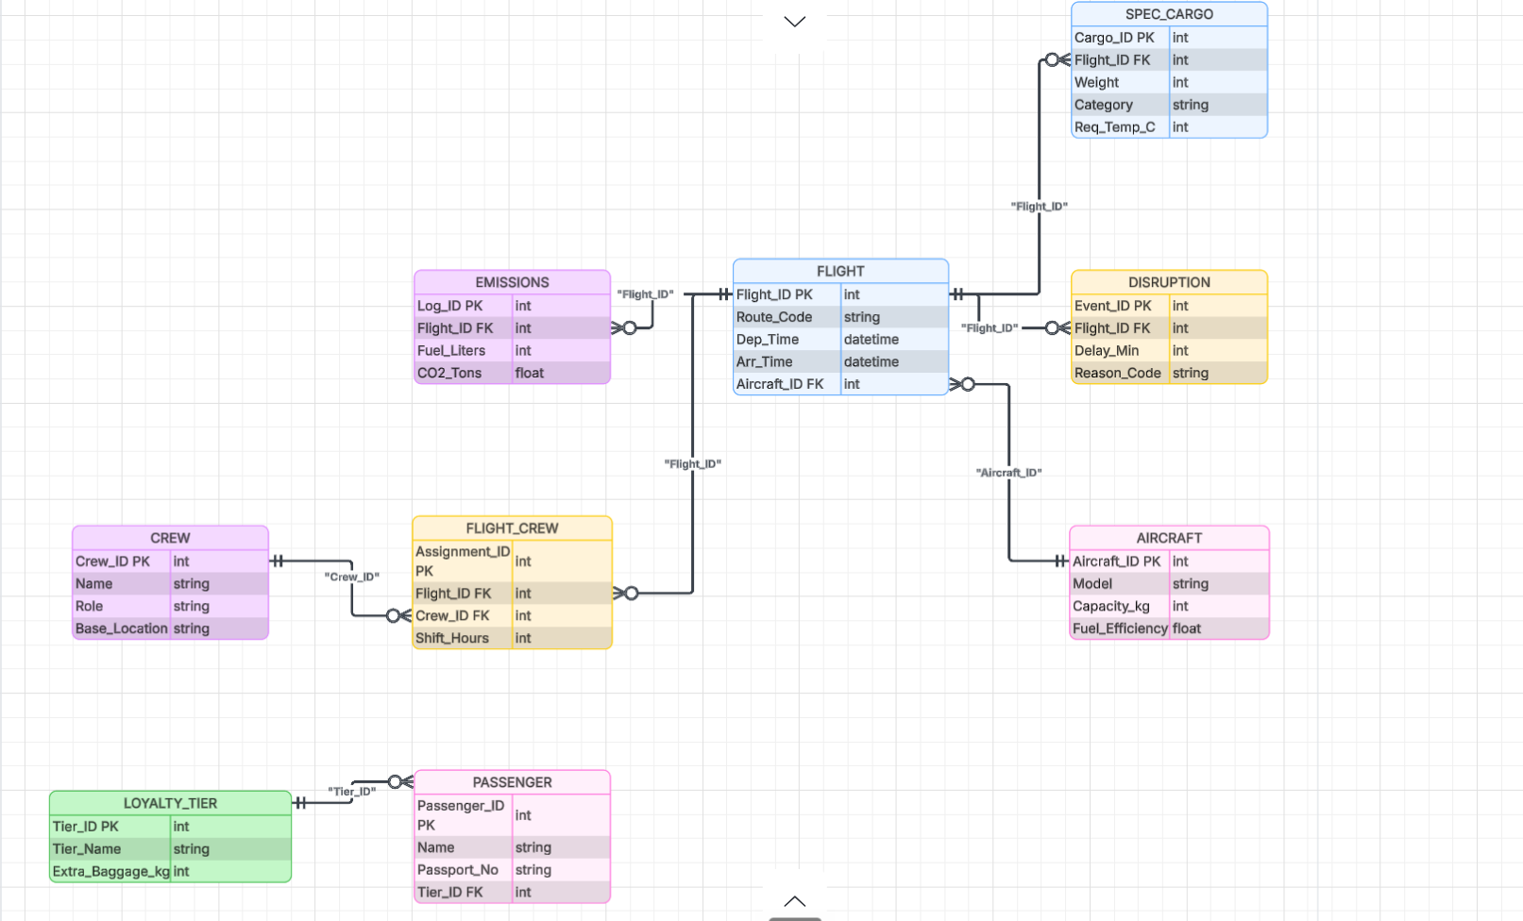

EXECUTION OF THE SQL QUERY

1. TABLE CREATION WITH ALL CONSTRAINTS

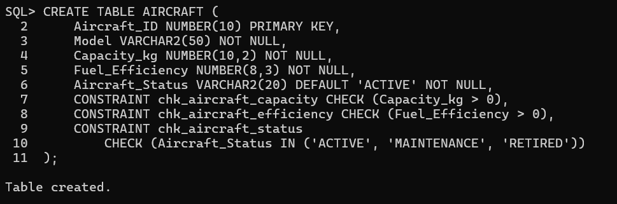
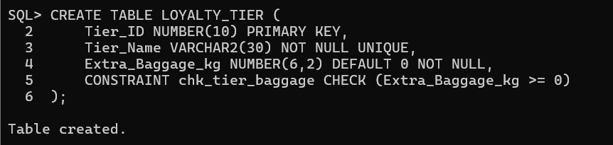
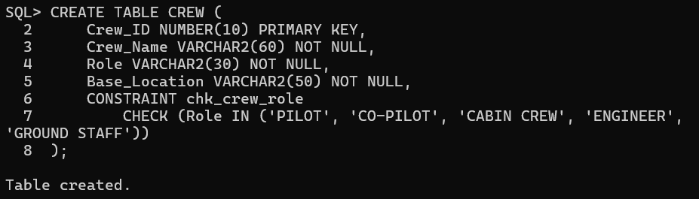
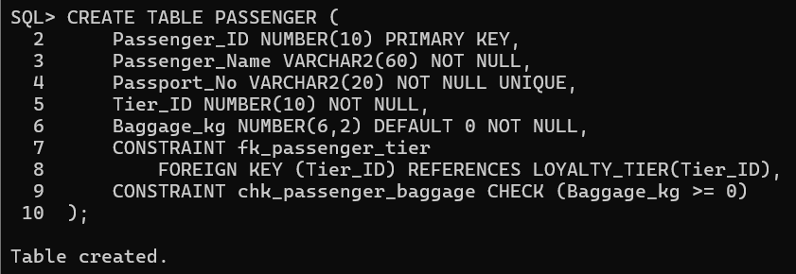

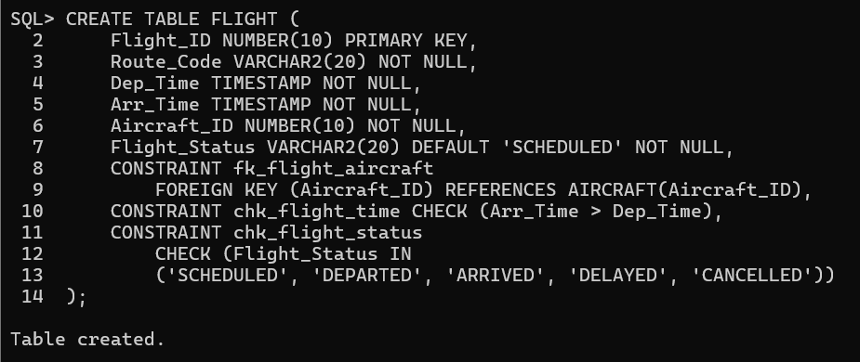
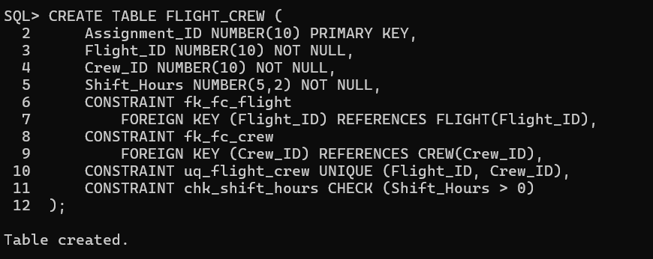
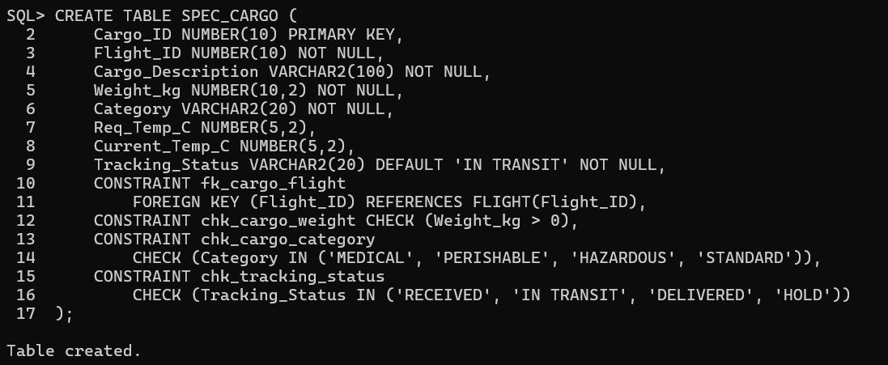

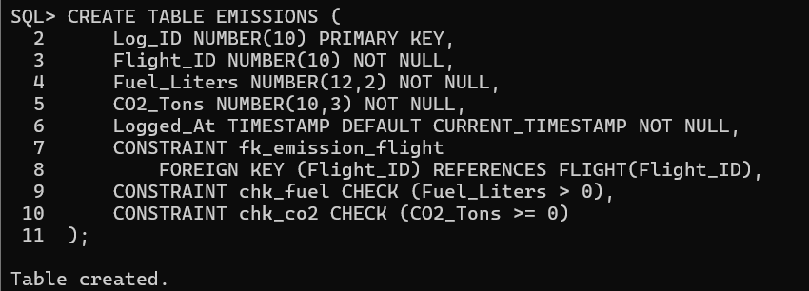
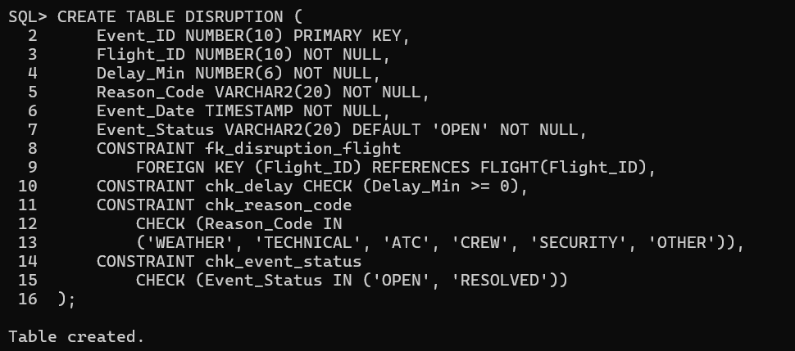

2. INSERTION - 5 ROWS PER TABLE
Aircraft table:
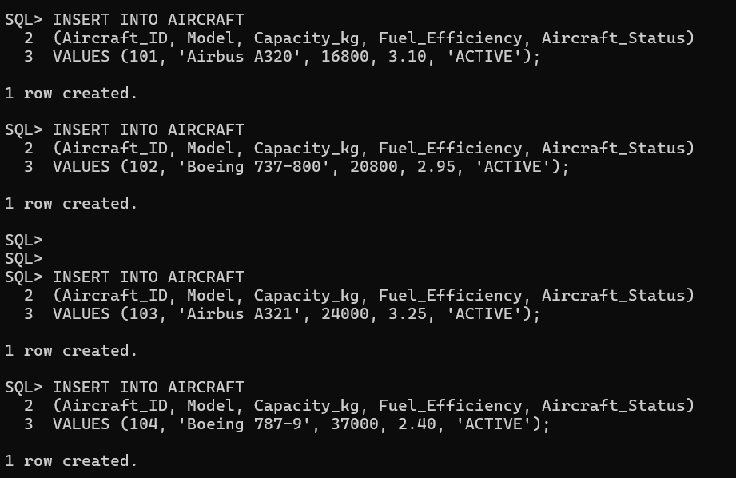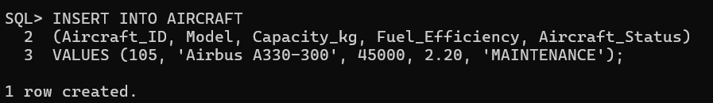
Loyalty_tier table:
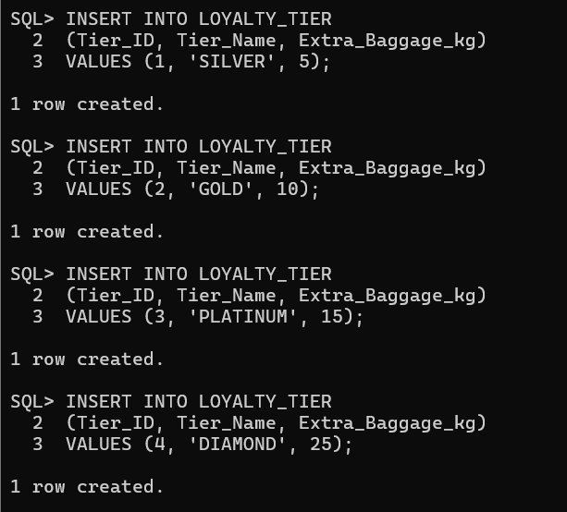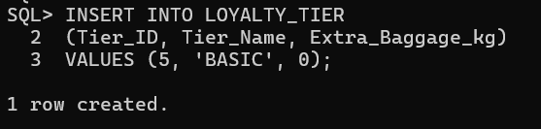
Crew table:
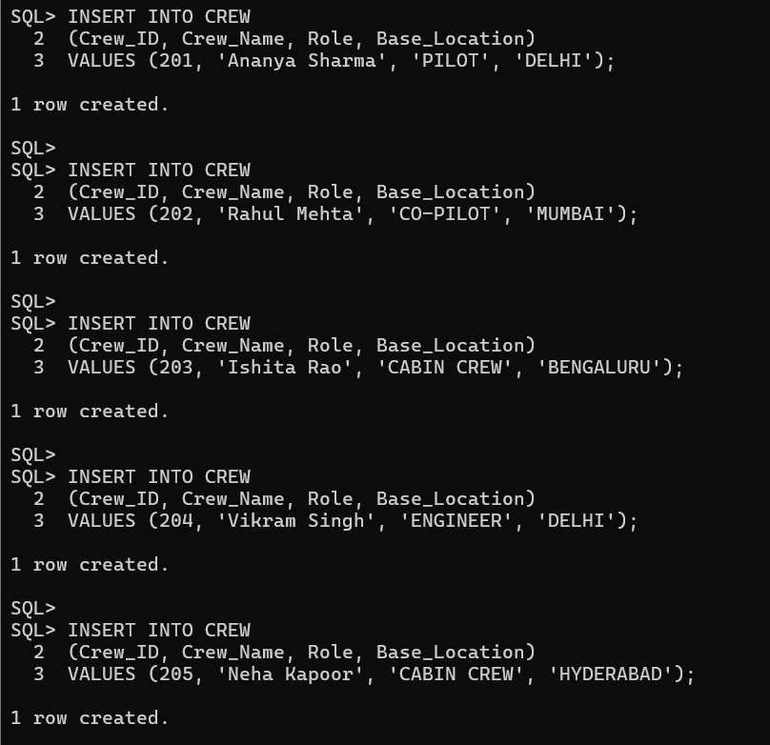
Flight table:
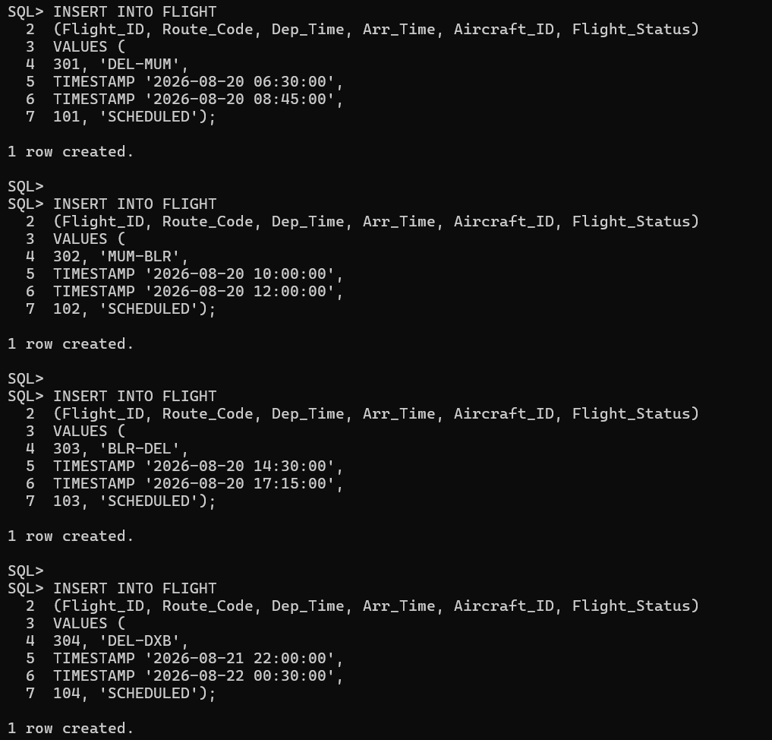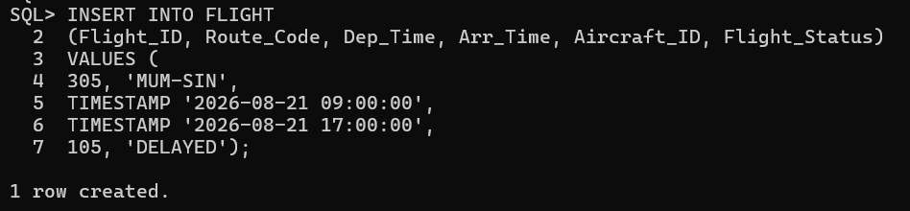
Flight_crew table:
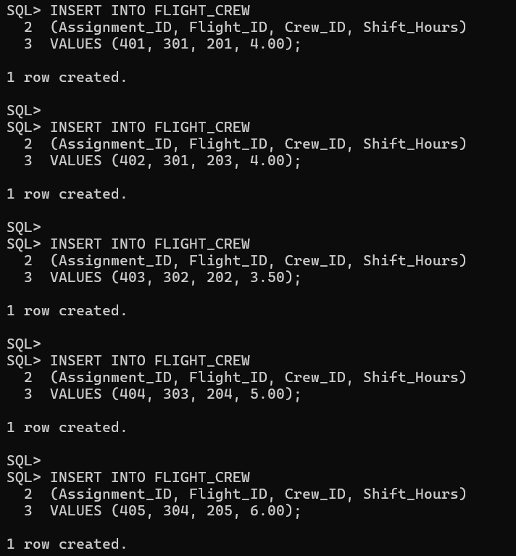
Passenger table:
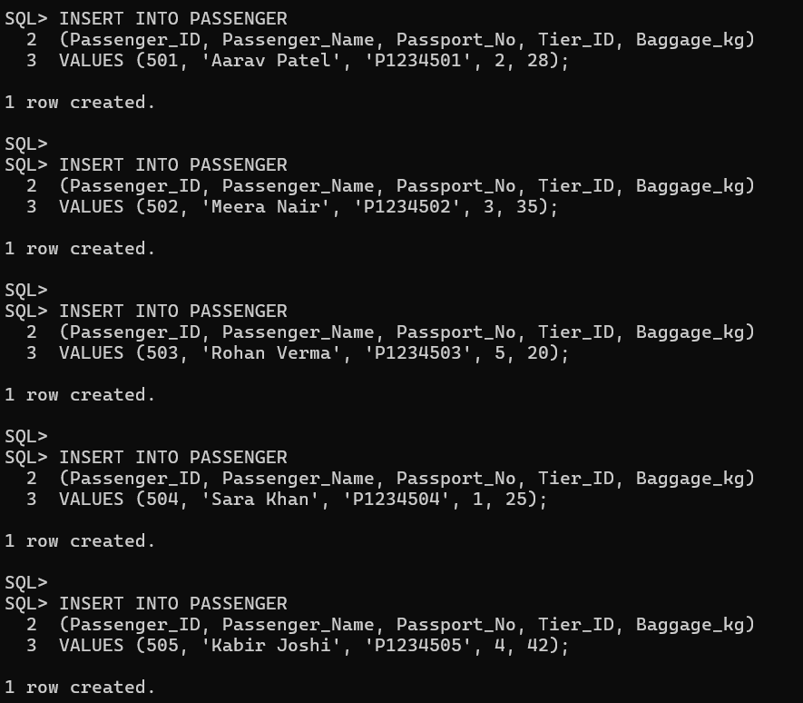
Spec_cargo table:
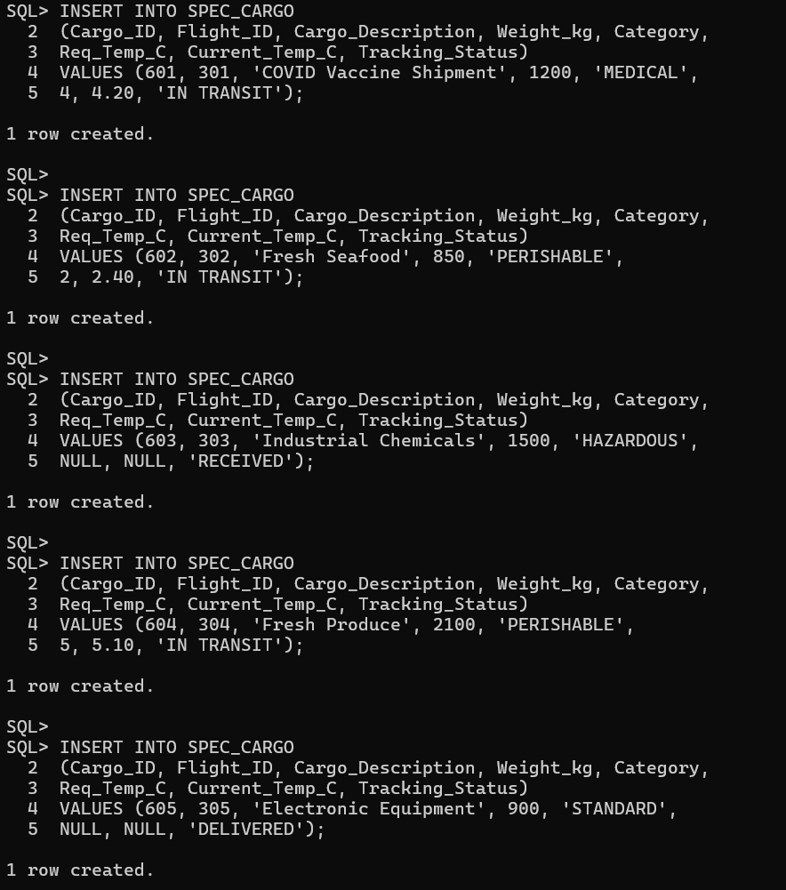
Emissions table:
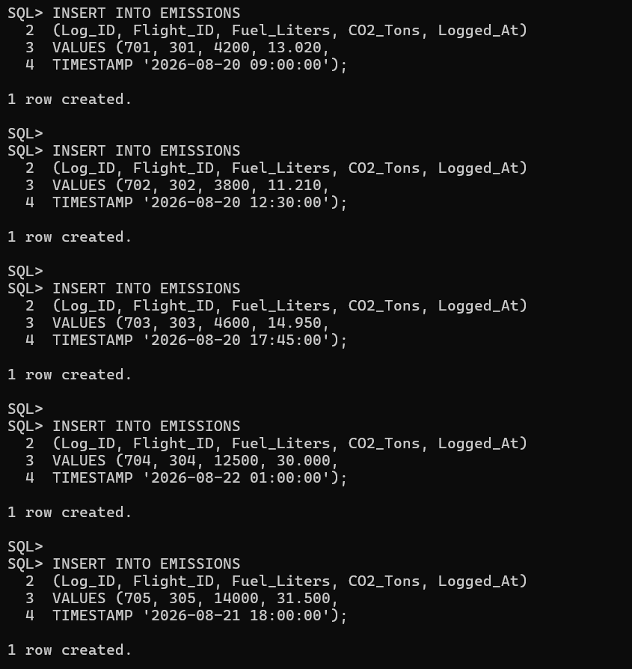
Disruption table:
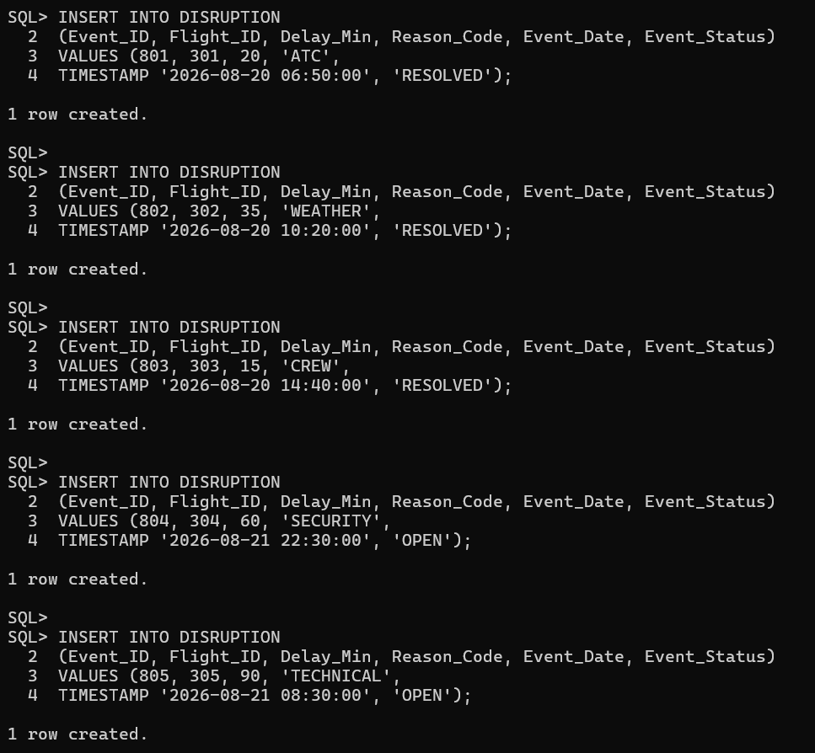

3.DELETION DEMONSTRATION:
Aircraft table:
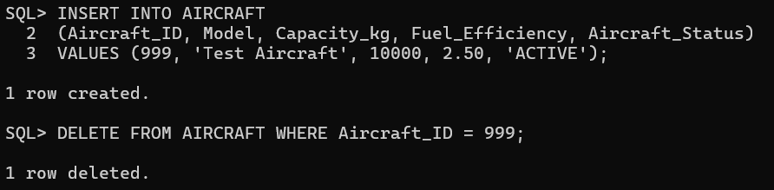
Loyalty_tier table:
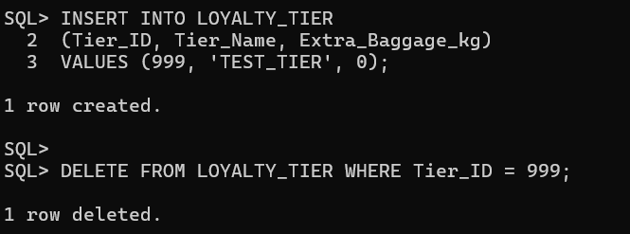
Crew table:
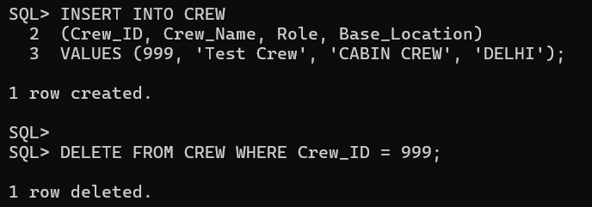

Flight table:
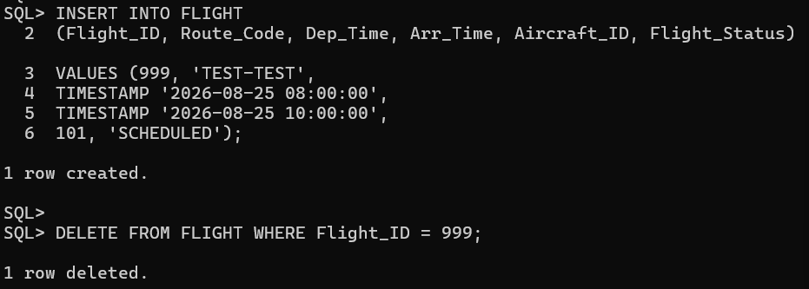
Flight_crew table:
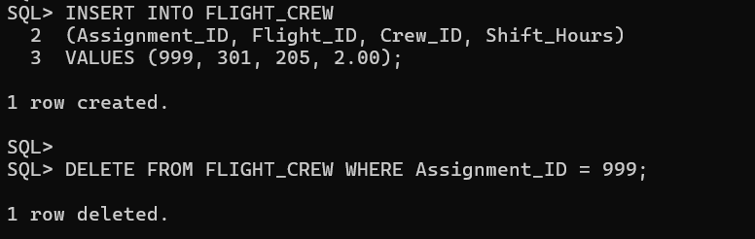
Passenger table:
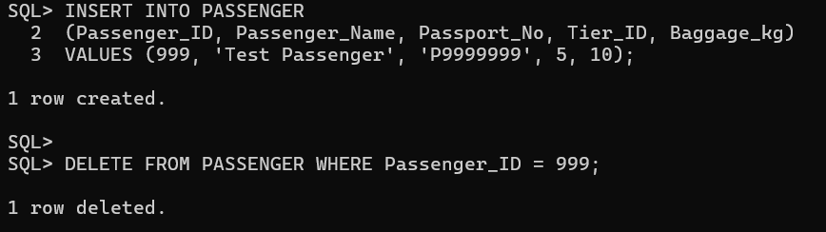
Spec_cargo table:
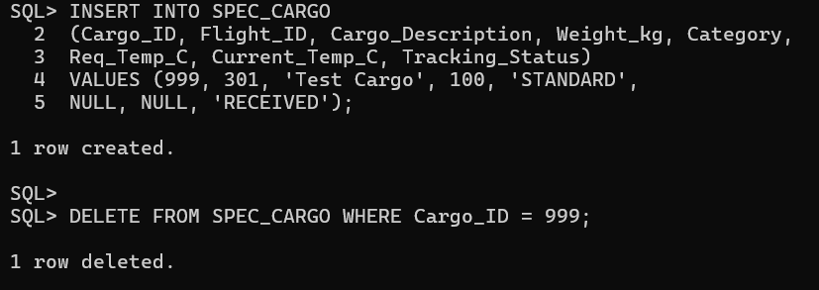

Emissions table:
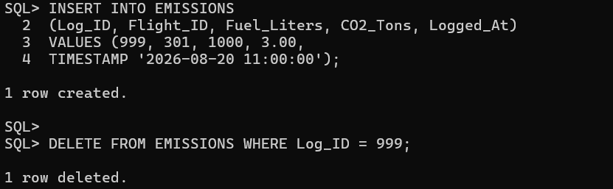

Disruption table:
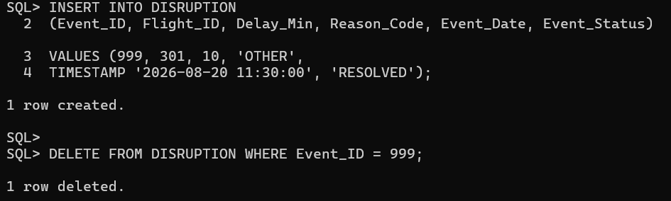

4.UPDATION - ONE UPDATE ON EACH TABLE

Aircraft table:
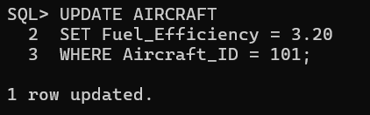
Loyalty_tier table:
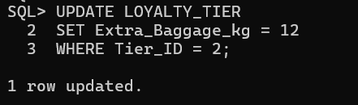
Crew table:
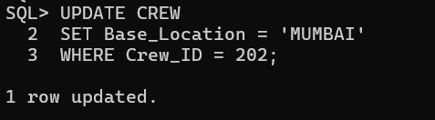
Flight table:
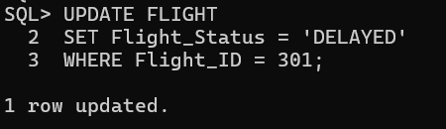
Flight_crew table:
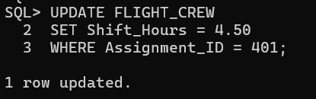

Passenger table:
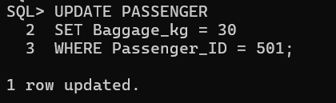
Spec_cargo table:
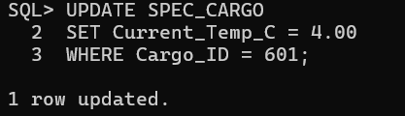
Emissions table:
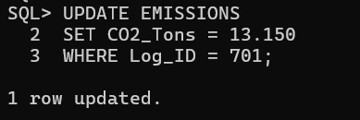
Disruption table:
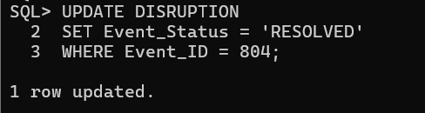

5.SELECT QUERIES

Flight table:
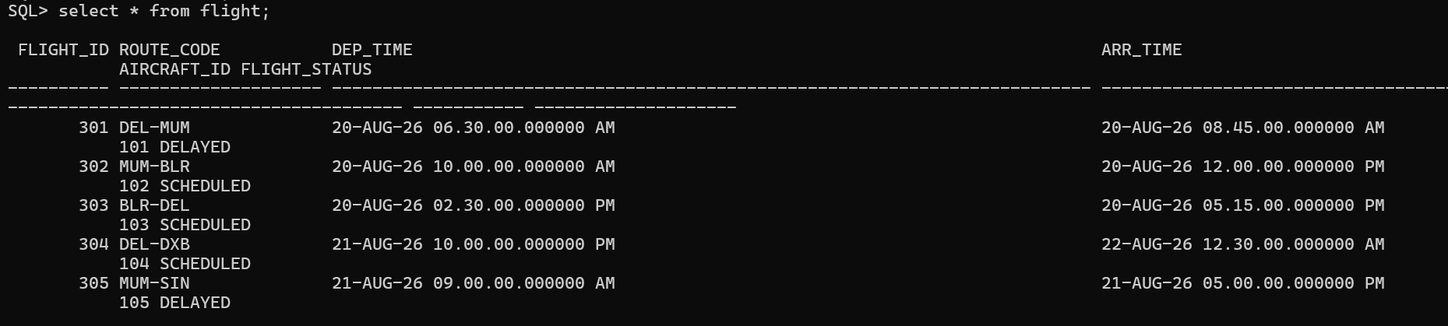
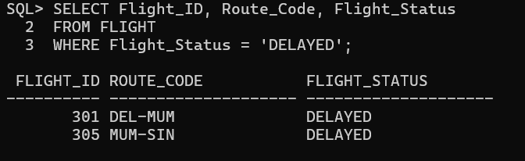
Passenger table:
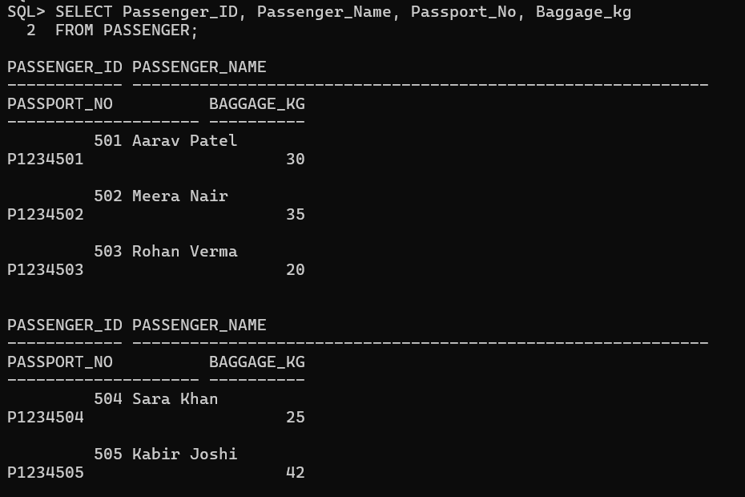

6.SINGLE-ROW FUNCTIONS

Aircraft table:
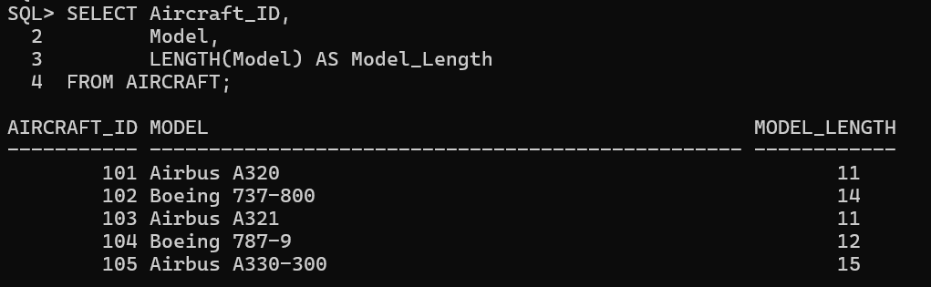
Crew table:
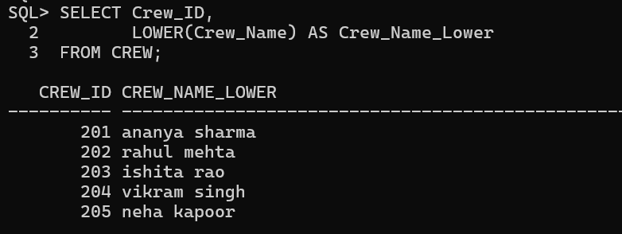

Passenger table:
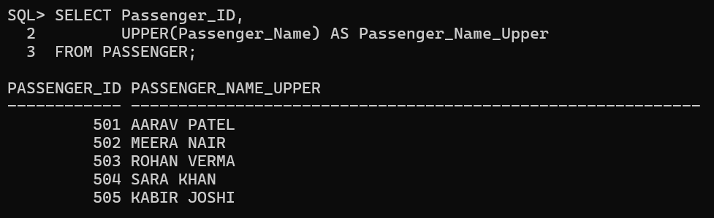

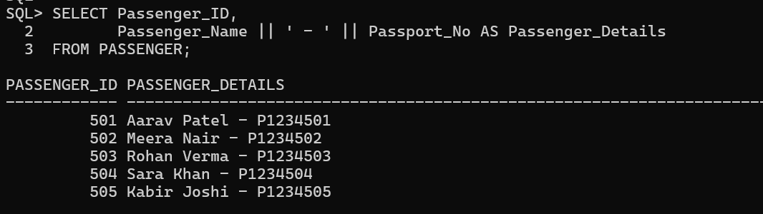
Spec_cargo table:
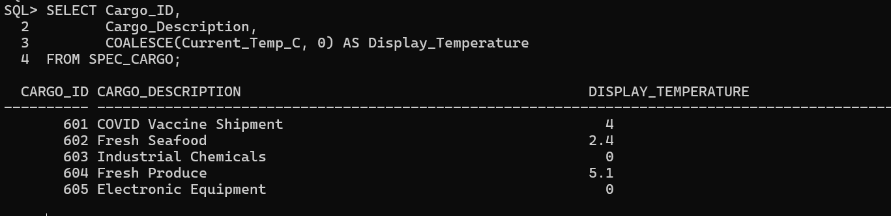
Emissions table:
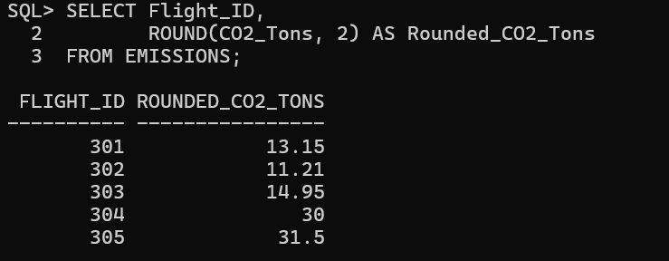

7.AGGREGATE FUNCTIONS

Flight table:
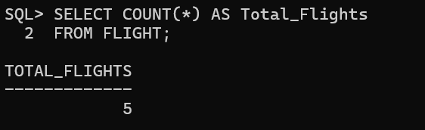
Spec_cargo table:
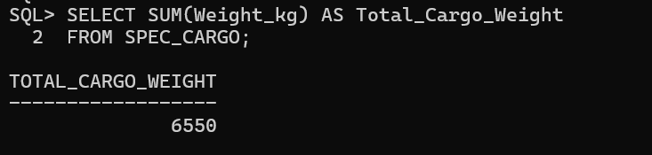
Emissions table:
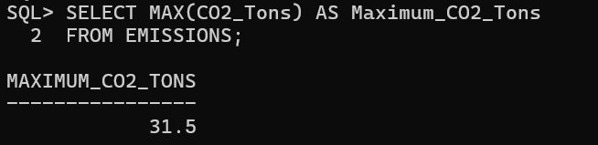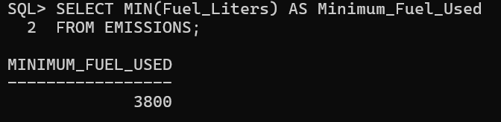
Disruption table:
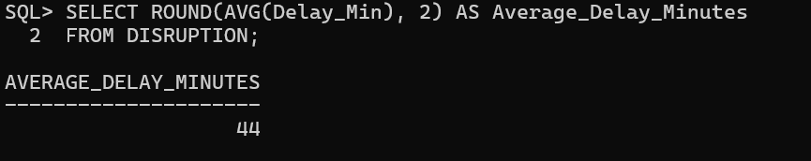

8.GROUP BY:

Flight table:
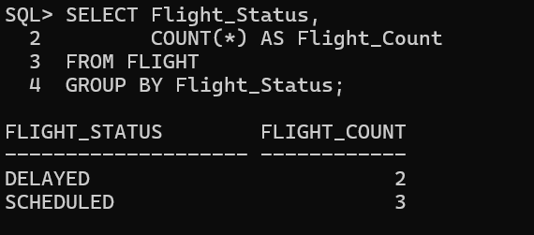
Spec_cargo table:
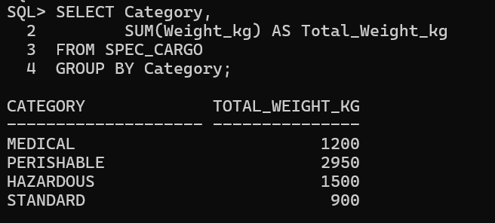
Disruption table:
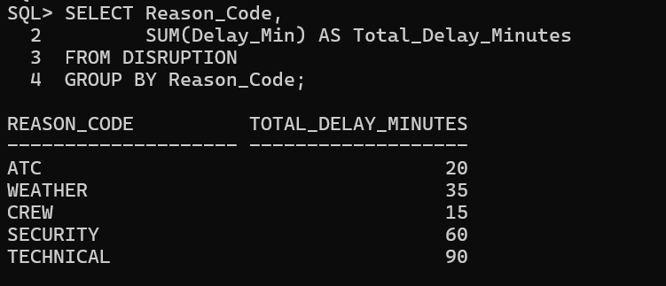

9.HAVING:

Spec_cargo table:
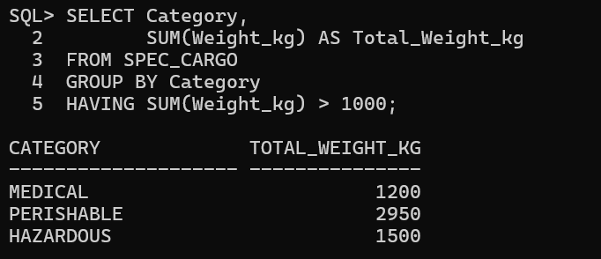

Disruption table:
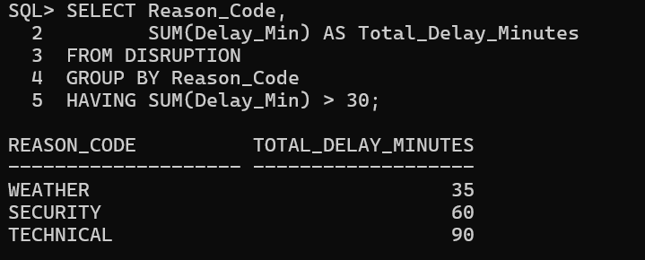

10.SUBQUERIES:

Aircraft table:
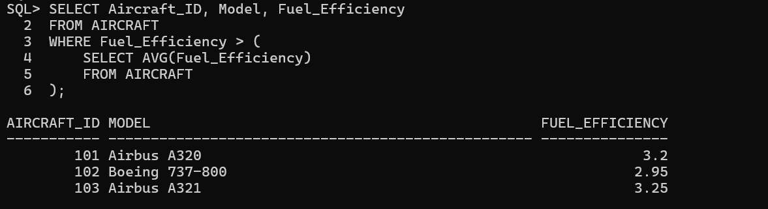
Passenger table:
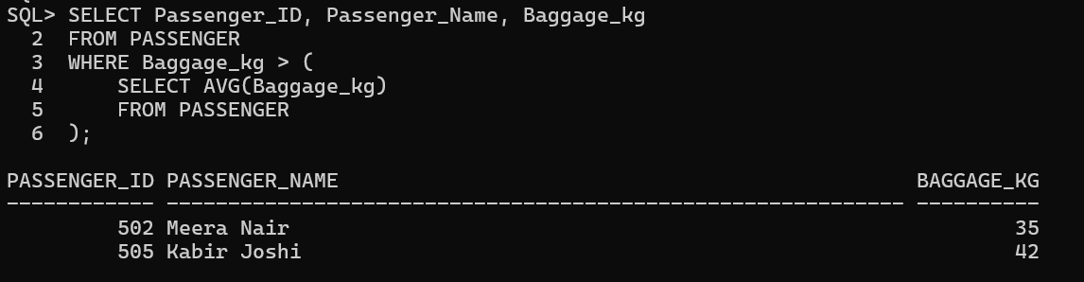
Emissions table:
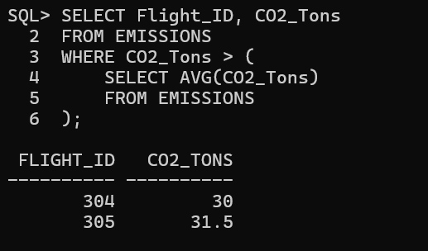

11.JOIN QUERIES

Aircraft table AND Flight table:
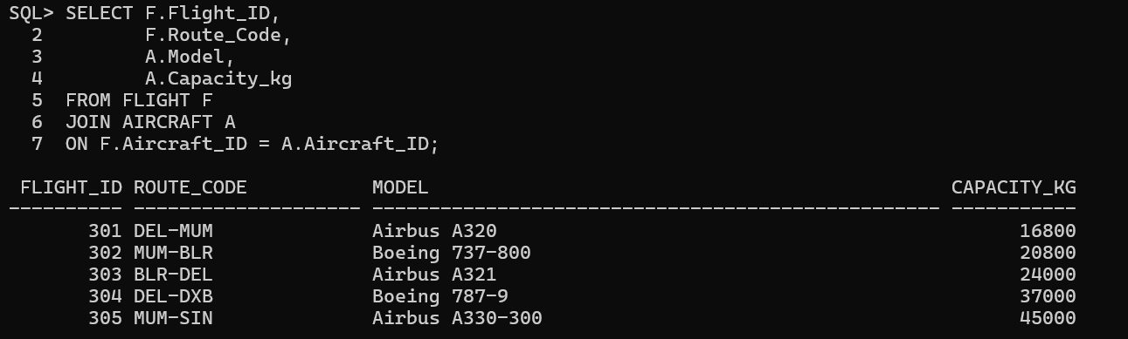
Loyalty_tier table AND Passenger:
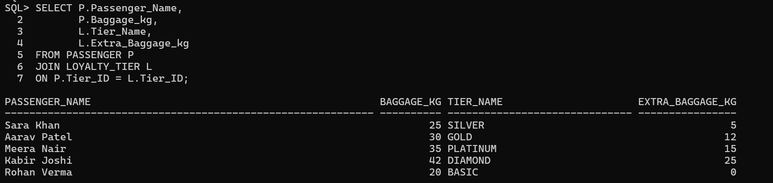

Crew table AND Flight table AND Flight_crew table:
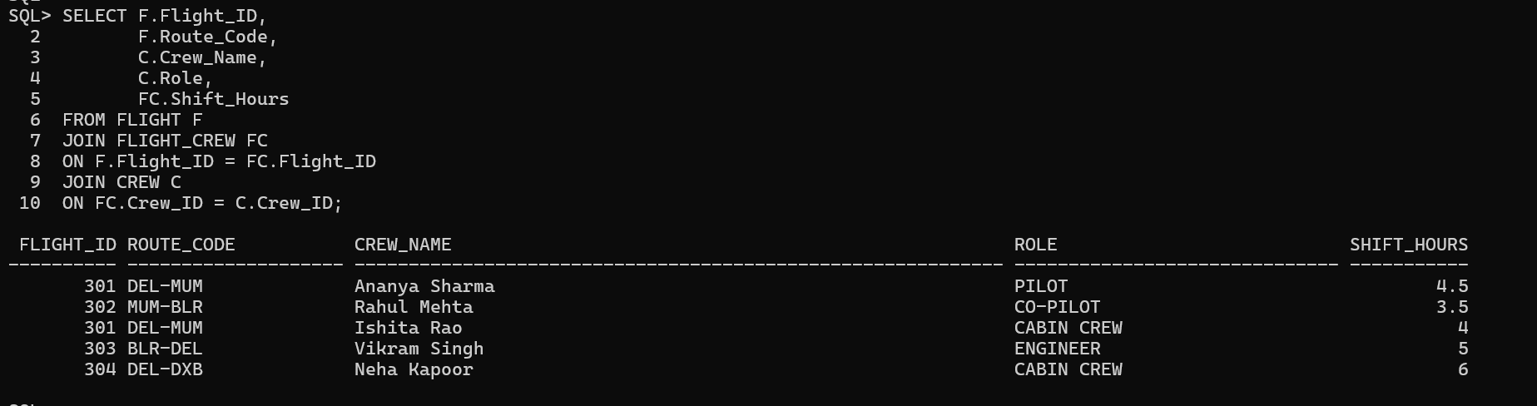

Spec_cargo table AND Flight table:
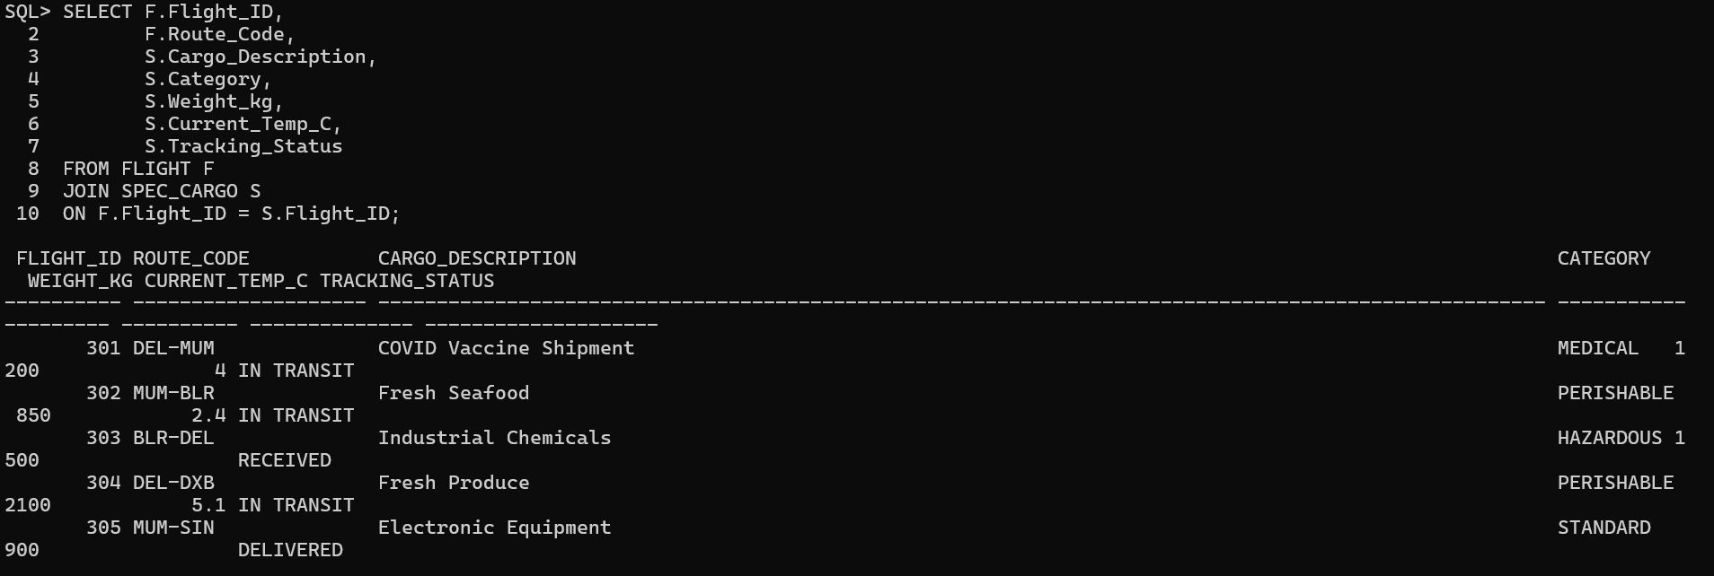

Flight table AND Aircraft table:
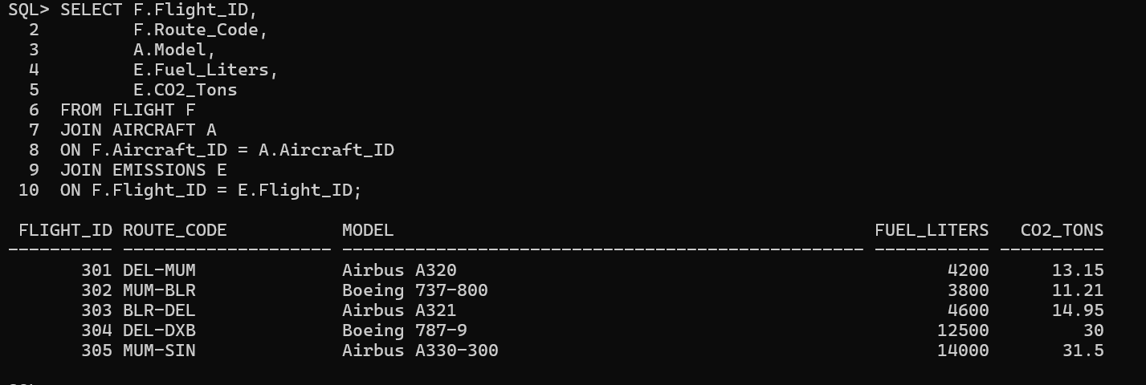

Disruption table AND Flight table:


